
Aim:
Create Poker Estimation for the user stories - Music Playlist Batch Creator Project.
POKER ESTIMATION:
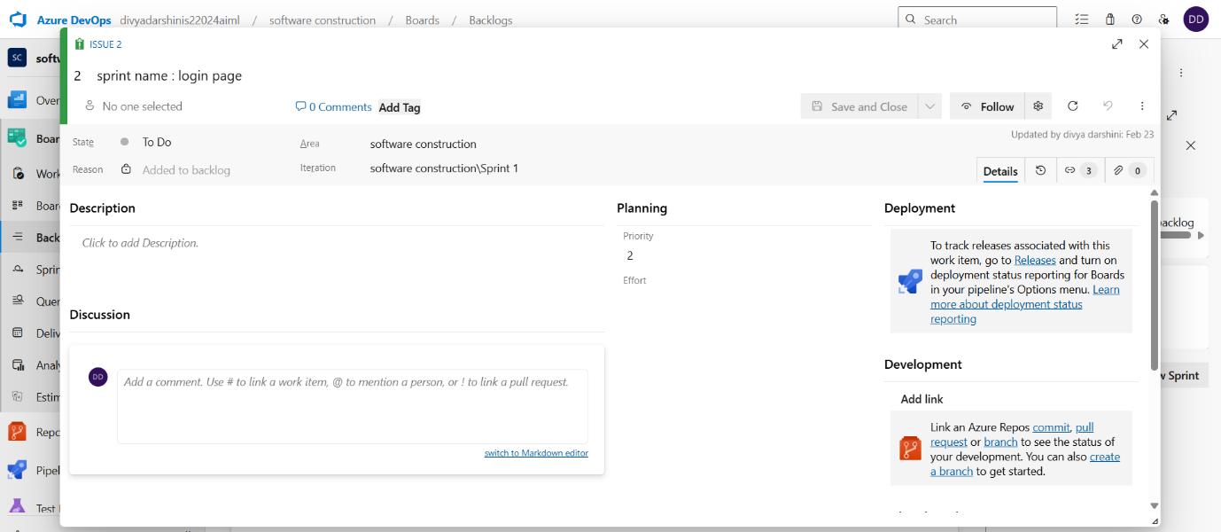
Result:
The Estimation/Story Points is created for the project using Poker Estimation.

